LAB # 1
Introduction to Eclipse IDE
OBJECTIVE
Introduction to Eclipse IDE, creating projects, its classes and mapping UML class diagram in to java code.
Lab Task:
Write the java code with the help of the given class diagram of Hospital Management System.
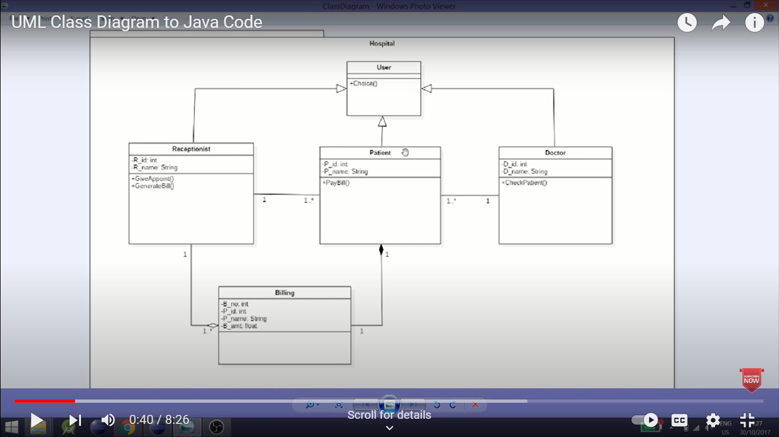

User Class:
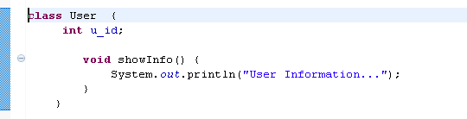
Doctor Class:
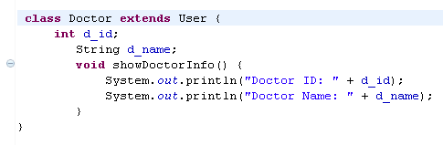
Patient Class:
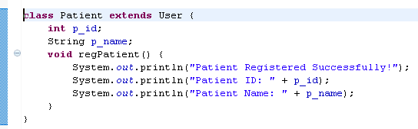
Receptionist Class:
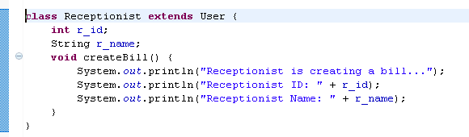
Billing Class:
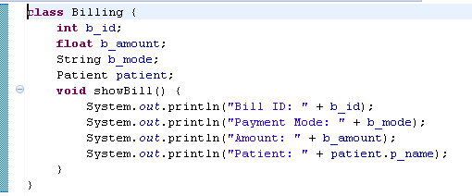
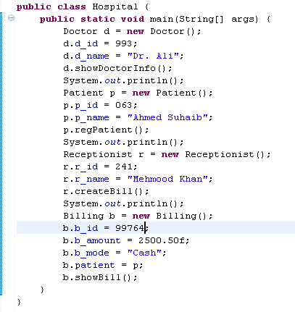
Main Class: Output:
